# CS 255 System Design Document Template

## UML Diagrams

*

### UML Activity Diagrams

Use Case for Booking in-person lessons and Use Case for registering for the course.

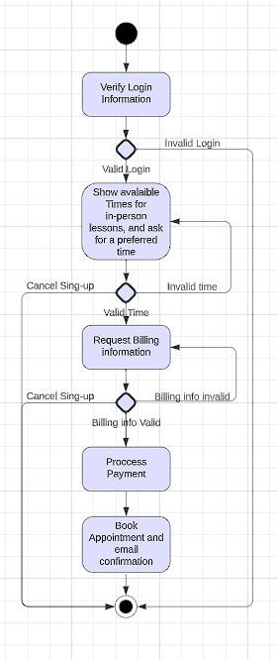

### UML Sequence Diagram

Sequence Diagram for students booking in-person lessons.

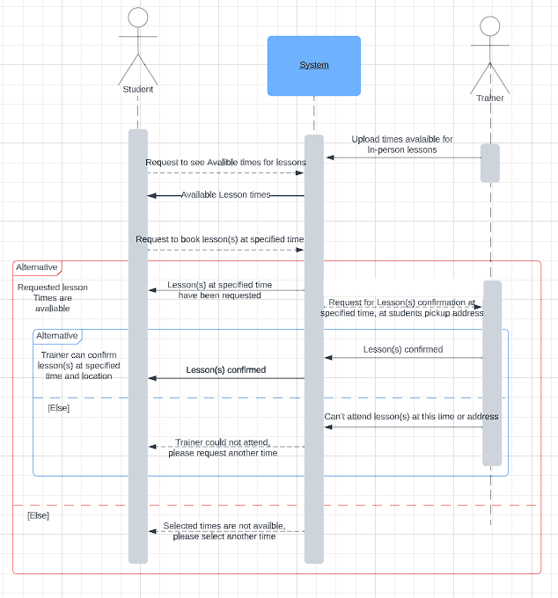

### UML Class Diagram

## Technical Requirements

Based on these diagrams that have been created, there are several technical requirements needed. The hardware needed for this system will be computers at the office, to be used by the secretaries, IT officers, and the admin. There will also need to be a Wi-Fi connection for those computers, but because we are using a cloud server, no physical server will be needed in the office. The software stack that is used to implement this system will be the MERN stack. Which is a stack that uses JavaScript throughout the stack, it is fast to develop and the current industry standard.

Visual studio code will be used to write, modify, and design the code for this application. This website will be built from HTML and will feature all of the standard safety features that come with it, such as REST API.